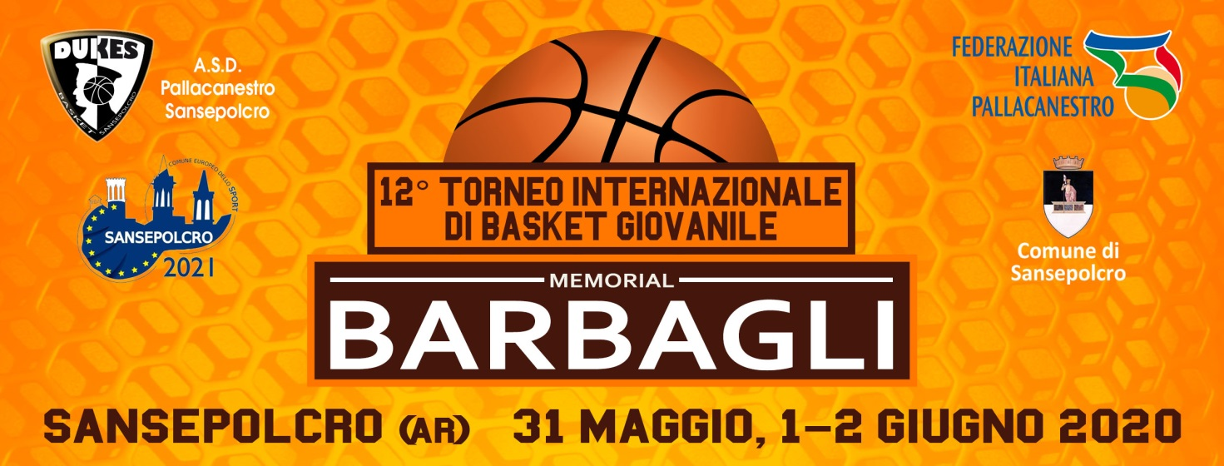

TECHNICAL INFORMATION AND TOURNAMENT FO
INFORMATION AND MEMBERSHIP
_____________ ___________

The Dukes Basketball Sansepolcro is pleased to invite you to the 12th National Tournament Basket Memorial Professor Pellico Barbagli reserved for Category Uncompetitive Eagles 2010 (allowed 2011), Competitive Eaglets 2009 (allowed 2010), Rookies 2008 ('09 allowed), Category Under 13 Male 2007 (allowed '08), Under 14 Male 2006 (allowed ’07), Under 15 Male 2005 (allowed ’06), Under 16 Male 2004 (allowed ’05), Under 18 Male 2002 (allowed ’03 and ‘04), Under 14 Female 2006 (allowed ’07 and ’08), Under 16 Female 2004 (allowed ’05 and ’06) held in Sansepolcro in the period 31 May - 2 June 2020

GENERAL INFORMATION

· The tournament will take place over the weekend 31 May - 2 June 2020 with the
participation of teams divided into categories above indicated
· All stakeholders will field teams in 5-on-5 (eaglets Uncompetitive and Competitive in 4-
on-4).
· The entry fee for each team is set at € 140.
· Cost of the Tournament: 150 € per head from Sunday dinner to Tuesday lunch; coach is
free for every teams signed up.
· Monday 1 June will be organized in a single structure the "Tuscany Dinner", an event
open to all companies (both athletes and parents Executives) full of surprises for the
guests with Tuscan food, music, prizes and games for all .
· Water for all athletes offered by the organization.
· In the indoor stadium where the event will be divided an official photographer.
· The Dukes Basketball will provide participants with a couple of buses transporting
members of the teams.
RMULA

· The event will be divided into four mini-tournaments, each team will play at least 4
games in 3 days with a game on Sunday, 2 on Monday and 1 or 2 (including the final)
on Tuesday.
· E 'must have badge and identification of athletes and coaches.
·· The timing of the game will be 4 to 8 'minutes each for all categories male and female.
· The matches will be refereed by miniarbitri Fip.

MEMBERSHIP FORM

The Board of registration must be completed in all its parts and sent by e-mail to barbagli@basketdukes.it

PARTECIPATING COMPANY
City
Address
Delivery Company
e-mail company
Responsible name
e-mail Responsible
Delivery Responsible
Registered categories | Unc. Eagles Compet. Eagles Rookies
 | Under13 M. Under14 M. Under15 M.
 | Under16 M. Under18 M. Under14 F.
 | Under14 F. Under16 F.
Game jersey color | Clear: Dark:
Any Communications

Subscription quote for each team is equal to 140 € and needs to to be paid registration to the tournament, through transfer banking on the coordinates :
Banca Intesa, agenzia di Sansepolcro · IBAN: IT92N0306971617100000002004
Specifying in the causal, name of society and categories recognized.

